The first thing you will see is an empty black box, this is a side effect of the script I am using to run the Free File Sync setup. You can ignore this, it will close itself once setup has finished.

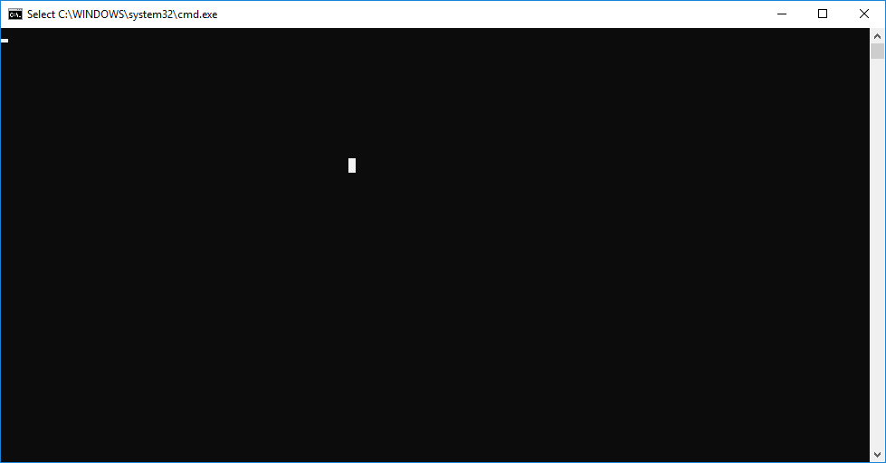

After launching the installer, you get the standard license agreement. FreeFileSync uses the GNU Public License which makes it free for us! You want to accept the agreement then click next.

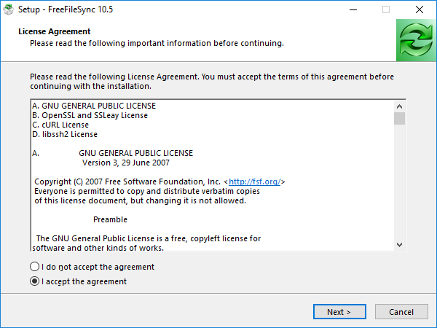

On the next window, it will ask for you to specify the install location. We are using the default location, so just click next.

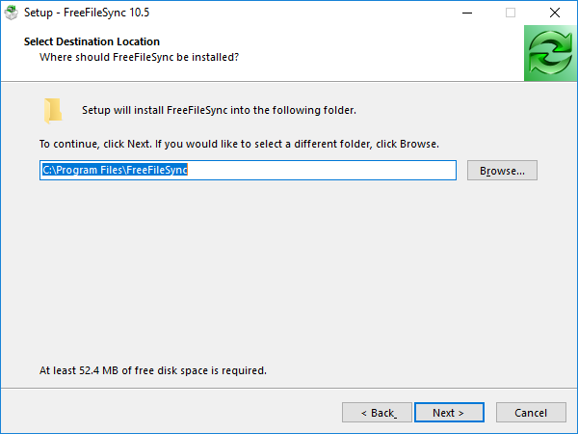

The next screen asks for the version and whether or not to create shortcuts. We use a local installation, and create no shortcuts because the parts we need are hard coded into our HANDS GUI. We want to make sure the shortcut options are unchecked, then click next.

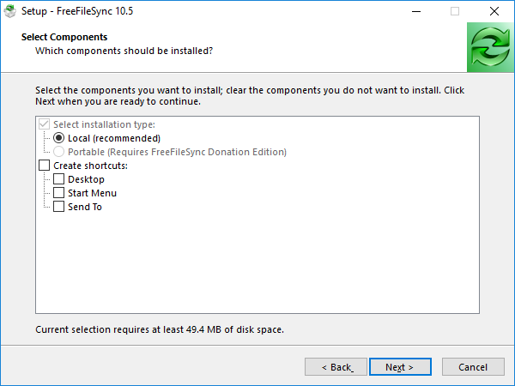

Free File Sync, as of version 10, no longer has advertisements, and is instead run completely by donations. Rather than change his installation files, he changed his ads into random images of animals. Enjoy (also, click next).

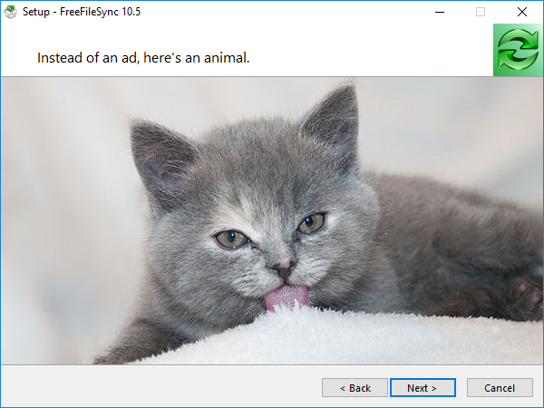

The next screen will display a progress bar, it will automatically change when it has finished.

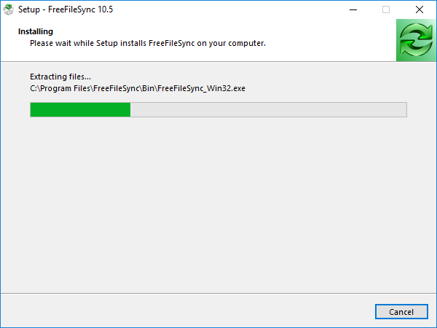

The final screen will show you that it has completed the setup, and give us the option to donate. Perhaps, one day, we will be able to help fund this wonderful program that makes the HANDS GUI what it is, but until then, we will just click Finish.

